

TRANSACTION ANALYSIS FOR ALL POSCLOUD CLIENTS.

*FRIDAY 23 SEPTEMBER 2022*

Contents

FBC IPOS 2

NMB PAY 263 3

NMB TAPCARD 4

SUMMARY 5

# FBC IPOS

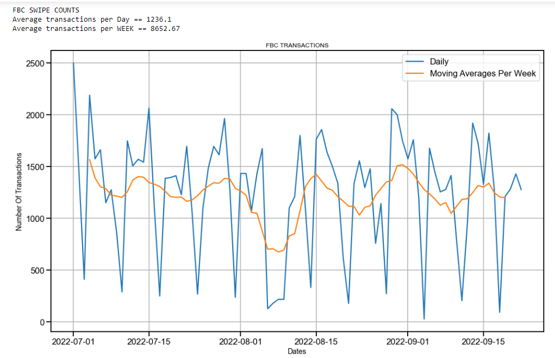

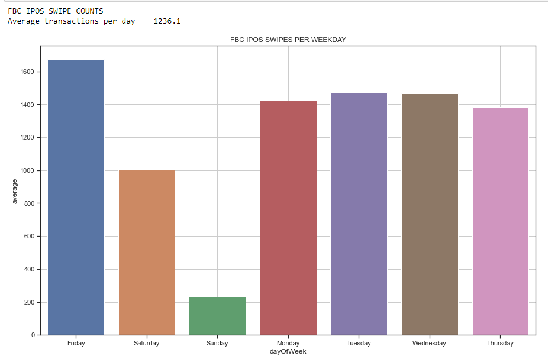

# NMB PAY 263

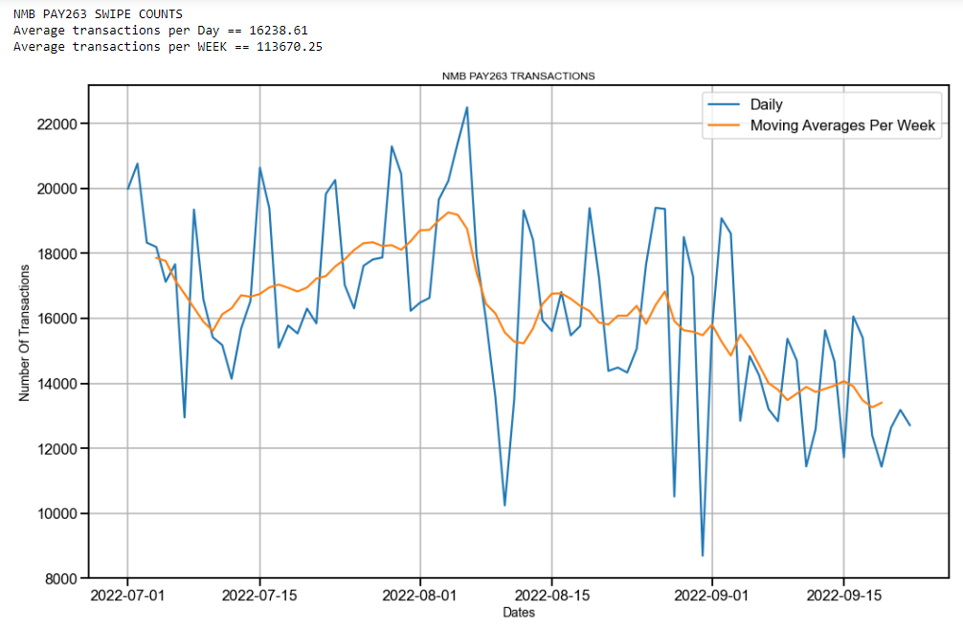

However. NMB Pay 263 number of swipes per day are decreasing with a high negative gradient.

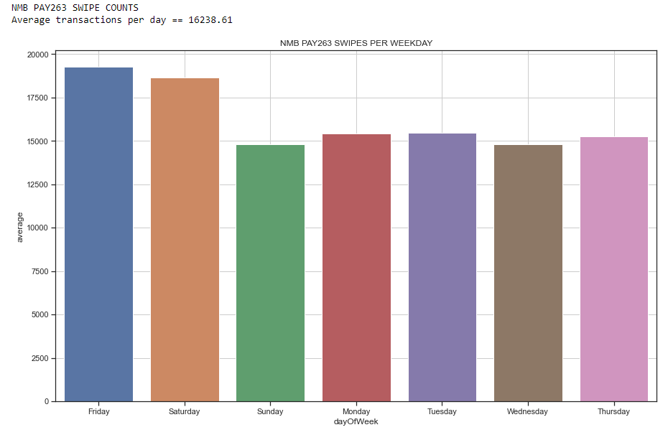

# NMB TAPCARD

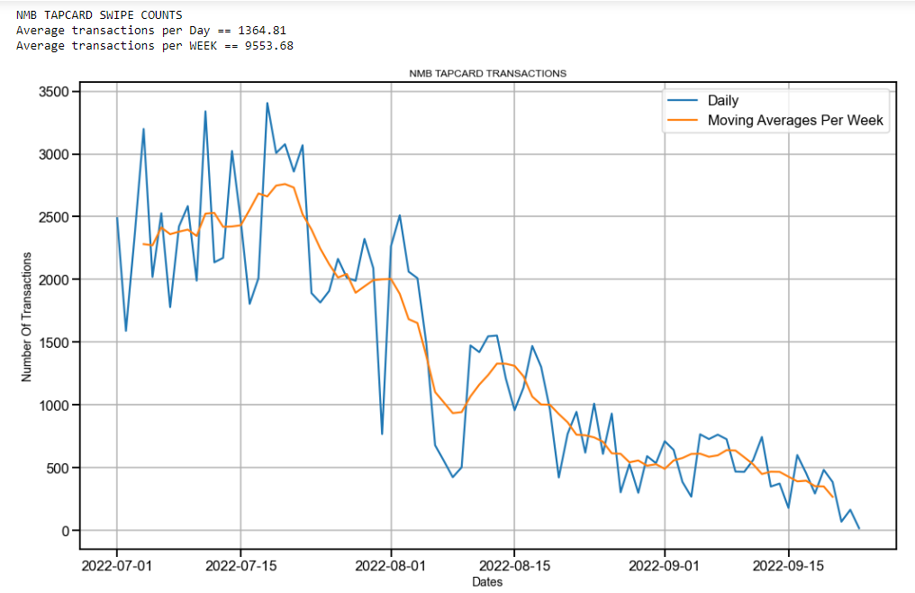

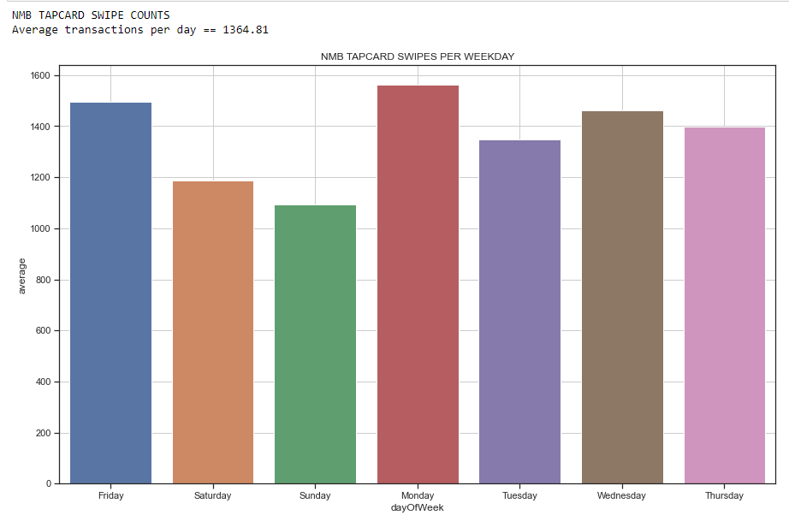

# SUMMARY

FROM ALL CLIENTS ABOVE POCLOUD PROCESS UPTO 123 559 TRANSACTIONS PER WEEK NMB PAY263 BEING THE HIGH TRAFFIC PLATFORM HOWEVER NMB PAY263 TRANSACTIONS PER DAY ARE DECREASING.